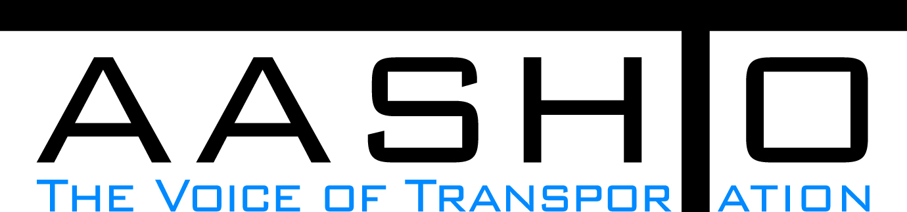Domestic Scan Proposal Form
AASHTO is soliciting topic proposals for a Calendar Year 2014 US Domestic Scan Program (NCHRP Panel 20-68A). Each selected scan topic will be investigated through site visits to three to six locations for approximately a two week period or less (type 1), by webinar, (type 2) peer exchange, or (type 3) conducted by a group of eight to 12 transportation professionals with expertise in the selected topic area. Proposed topics should meet the following criteria:
- Address an important and timely need for information by transportation agencies;
- Are of interest to a broad national spectrum of people and agencies;
- Are complex and also “hands-on,” meaning they lend themselves particularly well to exploration through on-site visits; and
- Are sufficiently focused that the tour participants are able to investigate and understand key issues in the limited time available on the tour.

Before submitting your proposal it is highly recommended that you read What Makes a Good Scan Topic Proposal http://www.domesticscan.org/what-makes-a-good-scan-topic-proposal
This form is designed to collect the full length of your proposal. Sections requiring essays have unlimited space for you to use. Contact information has some limited text. Use your TAB→ key to advance to the area where you need to complete information.
Proposals should be returned no later than OCTOBER 15, 2013.
IMPORTANT NOTE on How to save your document: LastNameFirst Initial, underscore_Organization Acronym _CY2014.
Saved Document Name Example: VitaleM_AASHTO_CY2014
If you have more than one, add a number after first initial: VitaleM1_AASHTO_CY2014

Domestic Scan Proposal Contact Information
Name | JEFF CASPER | Address | 4501 S. 2700 W.  P. O. Box 145730  Salt Lake City, UT 84115-5730
Title | Equipment Operations Manager | E-mail | jeffcasper@utah.gov
Member Department | UDOT | Telephone number | (801) 965-4976
AASHTO Committee | NCHRP 20-68A | Date of submission

Title of Proposed Scan: How do States deal with limited funding to identify and prioritize equipment needs. In addition how do other states set goals for utilization and how does that factor into prioritization.

Problem Statement (What topic is to be examined? What drives the need for the scan? Why now?)
With the current economy most DOT budgets are reducing their funding to replace new equipment.
The cost of purchasing new equipment keeps inflating every year so DOT's are faced with replacing less equipment each year.
State DOT's can benefit from sharing information on expected equipment life cycles, expected usage, equipment sharing and utilization.
Also an analysis of new equipment cost vs repairing exsisting equipment and or refurbishing exsisting equipment.

Scan Scope (What specific subject areas are to be examined? Which cities and states might be visited? Which agencies/organizations (including specific departments or types of staff if applicable)?
1) Proposed Scan scope subject areas
a) New equipment needs
b) Existing equipment expected life cycles
c) Dealing with utilization, what is the expected usage and how underutilized equipment is dealt with

2) Proposed agencies/organizations to visit
a) Illinois Department of Transportation
b) Florida Department of Transportation
c) Virginia Department of Transportation
d) Arizona Department of Transportation
e) Ohio Department of Transportation
f) Nevada Department of Transportation
g) California Department of Transportation
h) Washington Department of Transportation
i) Wyoming Department of Transportation

Anticipated Scan Results (What key information is to be gained? What information is to be shared after the scan? Who would the audience be for this information?)
1) Determining the ideal criteria of when you should replace a piece of equipment
a) What models do other states have to prioritize their equipment needs?
b) What kind of success has been achieved with their current equipment replacement models?
c) Does utilization factor into equipment replacement criteria?
d) What is your agency's expected utilization for your specific types of equipment, such as a class 8 dump truck?
e) Strategies for gaining organizational acceptance

2) Proposed Scan audience
a) Other State DOT's
b) Share the findings from questions above (1a, b, c)

Benefits Expected (Including potential impacts on current technology or procedures)
1. To come up with the best practices for equipment management, based on equipment needs and utilization with limited funding options.

